Andrew Plum

CS 385

10/11/2024

Homework Portfolio Draft

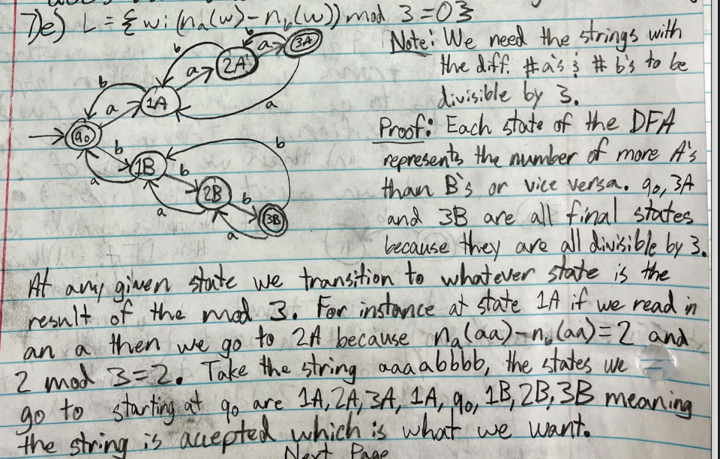Problem 1: HW 1 Question 7e

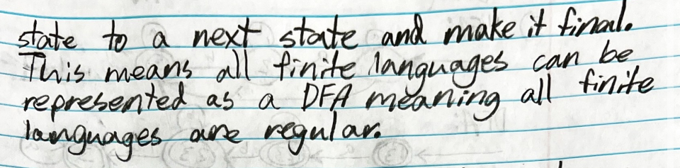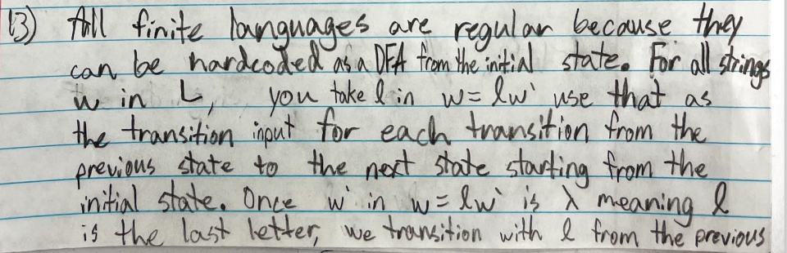Problem 2: HW 2 Question 13

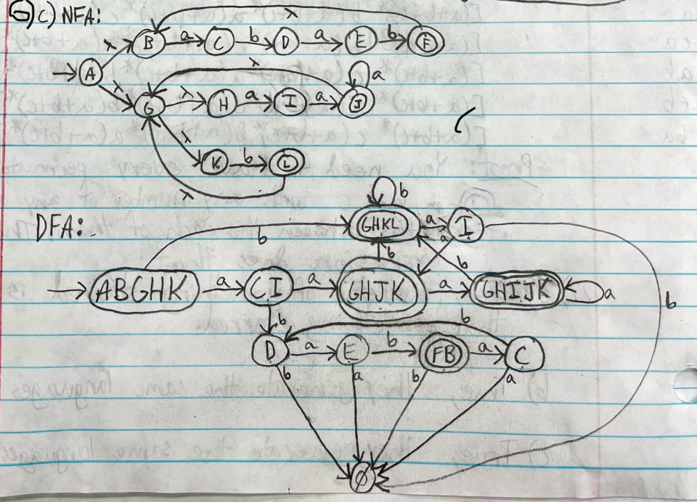Problem 3: HW 3 Question 6c

Problem 4: HW 3 Question 12c